WEB-BASED E-GOVERNANCE SYSTEM WITH DATA ANALYTICS FOR BARANGAY SAN ISIDRO, CANDELARIA, QUEZON

Arias, Jeric D. Garcia, Marc Jason Z. Litada, Kenneth
jericdatinggaling@gmail.com marcjsngarcia@gmail.com kennethlitada@gmail.com
09632571734 09165579849 09914385877

Magpuri, Jervy B. Magtibay, Justine Andrei A. Rañada, Paul Adrian L.
Jervy100718@gmail.com Andreimagtibay10@gmail.com asvpxadrian@gmail.com
09386403612 09562578598 09279388226

Abstract
Local government units at the barangay level continue to face challenges related to manual record-keeping, delayed service delivery, limited transparency, and difficulty in generating reports for decision-making. This study presents the development of a WebBased E-Governance System with Data Analytics for Barangay San Isidro, Candelaria, Quezon, designed to digitalize barangay transactions and improve operational efficiency. The system manages resident records, document requests, announcements, reports, and transaction monitoring through a centralized web platform. Integrated data analytics provide visual summaries of requests, population statistics, and transaction trends to support evidence-based decision-making. The system was developed using the Agile methodology to ensure adaptability to user requirements. Evaluation results from barangay officials and staff indicate that the system is highly acceptable in terms of functionality, usability, reliability, security, and performance. The study concludes that the proposed system enhances service delivery, transparency, and administrative efficiency at the barangay level.
Keywords: E-Governance, Barangay Information System, Data Analytics, Web-Based System, Local Government

I. INTRODUCTION
The rapid advancement of information and communication technology has transformed how governments deliver public services. In the Philippines, barangays serve as the primary point of contact between citizens and the government, handling essential services such as document issuance, community announcements, and resident record management. However, many barangays still rely on manual processes, resulting in slow transactions, data inconsistencies, and limited access to information. Barangay San Isidro in Candelaria, Quezon faces similar challenges, including time-consuming document processing, difficulty in monitoring transactions, and lack of analytical tools for planning and decision-making. To address these concerns, this study proposes a web-based e-governance system integrated with data analytics to streamline barangay operations, improve accessibility of services, and enhance transparency.

II. RELATED LITERATURE
E-governance systems have been widely recognized for improving efficiency, accountability, and service delivery in local government units. Studies have shown that web-based information systems reduce paperwork, minimize human error, and provide faster access to records. The integration of data analytics further enhances these systems by enabling government officials to analyze trends, monitor performance, and support informed decision-making. Previous research on barangay information systems highlights the importance of centralized databases, role-based access control, and realtime reporting. These systems contribute to improved governance by ensuring data accuracy, transparency, and responsiveness to community needs. The present study builds upon these concepts by incorporating analytics dashboards tailored to barangaylevel operations.
The reviewed literature emphasizes the growing importance of data analytics in organizational and governance contexts across different regions. Chen (2024), in an international study, defined data analytics as the systematic process of collecting and analyzing data to uncover patterns, trends, and correlations that support informed decision-making. Similarly, Kang (2023) highlighted its critical role in global business industries, where high-precision analytical techniques contribute to operational success. Wharton (2021), based on a global business analysis, noted that data analytics enables organizations to better understand customer behavior and needs. Supporting this, Grunberg (2024) emphasized that data analytics assists organizations worldwide in evaluating performance, reducing costs, and identifying inefficiencies. However, Chen (2024) also pointed out challenges such as poor data quality, lack of centralized data access, security concerns, and the rapid evolution of analytical technologies. Despite these challenges, studies such as Crawford (2025) and Shadbolt (2024), conducted in international governance settings, confirmed that data analytics strengthens evidencebased policymaking, transparency, regulatory compliance, and fraud detection, making it a valuable tool in public governance. In terms of system infrastructure, web-based systems are widely recognized as effective platforms for digital governance. Johnson (2023), in a global technology study, defined web-based systems as browser-accessible applications hosted on remote servers, offering high accessibility and cross-platform compatibility. Palma et al. (2023), in their international research on smart cities, identified web portals and web applications as major channels for implementing egovernance. Likewise, Adnan et al. (2022), in a global democratic governance study, emphasized the role of web-based e-participation tools in strengthening citizen involvement. The United Nations, through the World Summit on the Information Society (Waheduzzaman, 2022), promoted the use of ICT and web-based platforms to improve governance worldwide. Advances in web technologies, such as Web 3.0 discussed by Wensheng (2023) in an international context, further enhance security, decentralization, and data ownership. Additionally, Haque (2022), in a healthcare-focused global study, demonstrated the flexibility of web-based systems in improving data interoperability and decision support. Studies by Technology (2023) and Grepix Infotech (2024) further emphasized the cost-effectiveness, scalability, and security of web-based systems, making them suitable for government applications.The literature on e-governance highlights its transformative role in modern public administration at both international and local levels. Magana et al. (2025) defined e-governance as the use of digital technologies to enhance government operations and citizen engagement, based on international governance studies. In the Philippine context, Bajar et al. (2023) observed that the adoption of e-governance significantly increased during the COVID-19 pandemic as local government units shifted to digital processes. Pacano and Tayaoan (2024) further emphasized that e-governance has become a core component of governance systems worldwide. Notably, Quezon City’s award-winning e-governance initiatives, documented by Troy, Bajar, and Porsche-Ludwig (2021) and De Castro (2022), demonstrated how digital governance improves service delivery and citizen participation in the Philippines. On a global scale, Nasrudin (2020) and Othman, Razali, and Nasrudin (2020) identified e-governance as a key driver in achieving the United Nations Sustainable Development Goals (SDGs). However, Shkarlet et al. (2020) noted that developing countries, including the Philippines, continue to face challenges such as limited infrastructure, resource constraints, and digital literacy gaps. Despite these issues, Abesamis and Caramancion (2022), in a Philippine-based study, concluded that e-governance enhances transparency, accountability, and public trust in government institutions.

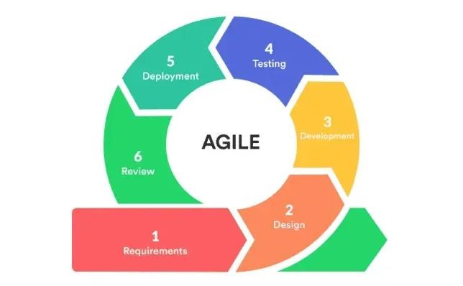
III.

RESEARCH METHODOLOGIES

Figure 1. Agile Methodology

The Agile Development Methodology is an iterative and flexible system development approach that emphasizes continuous collaboration, incremental progress, and responsiveness to change. Instead of following a rigid, linear process, Agile divides development into short cycles where system features are planned, developed, tested, and improved continuously. This approach enables early detection of issues, frequent user feedback, and continuous system enhancement, ensuring that the developed system remains aligned with actual user needs and operational requirements. Agile was applied in the development of the Web-Based E-Governance System to accommodate the evolving requirements of barangay officials and residents. Since local government processes may change over time, the Agile methodology allowed the development team to modify system features such as online document requests, transaction tracking, and reporting tools without restarting the entire project. Through regular testing and review, Agile contributed to improved system usability, reduced development risks, and timely delivery of functional system components. The system was developed using HTML, CSS, and Bootstrap as its core front-end technologies. HTML provided the structural foundation of the web application, while CSS enhanced the visual presentation and user interface consistency. Bootstrap, a responsive front-end framework, was utilized to ensure cross-device compatibility, accessibility, and a user-friendly layout. The use of these web technologies supported Agile principles by enabling rapid prototyping, easy interface adjustments, and efficient collaboration during development iterations. In addition, data analytics was integrated into the system to support evidence-based decision-making at the barangay level. Collected transactional data were analyzed to generate reports, track service performance, identify trends, and monitor operational efficiency. Through analytical dashboards and visual summaries, barangay officials are able to gain insights into document requests, processing times, and service demands. The integration of data analytics enhances transparency, improves planning, and supports effective governance by transforming raw data into meaningful and actionable information.

A. System Architecture
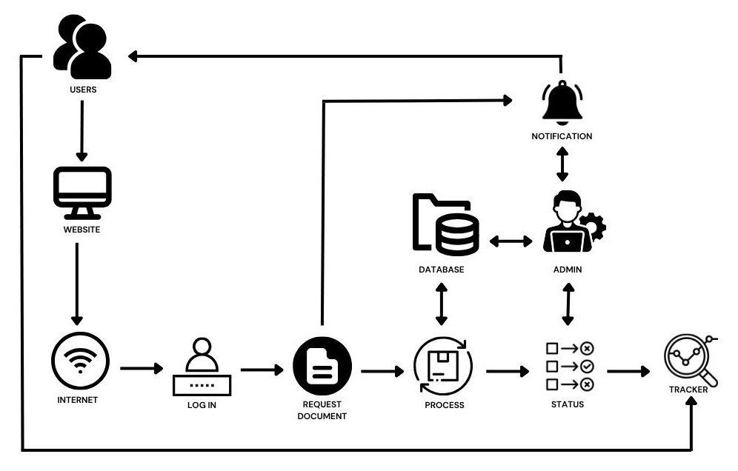

Figure 2. System Architecture
The system architecture of the Web-Based E-Governance System for Barangay San Isidro is designed to illustrate the interaction between residents, barangay staff, and system components in delivering efficient digital public services. The system follows a web-based architecture where residents access the platform through a browser using mobile devices or computers. Through the user interface, residents can register, log in, submit document requests, and monitor the status of their transactions. Available services include Barangay Clearance, Cedula, Certificate of Residency, Certificate of Indigency, and Business Permit. Upon submission, the system generates a unique reference code that allows users to track their requests in real time. On the administrative side, barangay staff access the system through a secured web-based portal. Administrators are responsible for managing user registrations, reviewing and processing document requests, and updating request statuses through a centralized dashboard. A super administrator oversees higher-level system management tasks, including managing admin accounts, assigning roles, and controlling system access to ensure security and proper authorization. All system data, including user information, transaction records, and document statuses, are stored in a centralized online database. This centralized data storage ensures data consistency, improves record management, and minimizes the risk of data loss associated with manual processes. Overall, the system architecture is designed to be secure, reliable, and user-friendly, supporting transparency, accessibility, and efficiency in barangay service delivery.

B. Block Diagram of the System
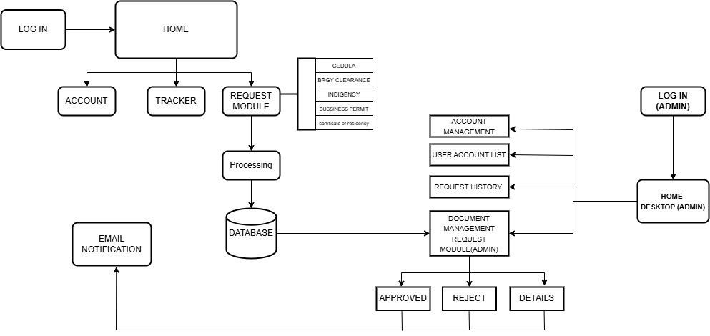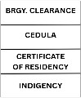

Figure 3. Block Diagram of the System
The block diagram illustrates the functional flow and interaction between users, system modules, and administrative components of the Web-Based E-Governance System for Barangay San Isidro, Candelaria, Quezon. Residents access the system through a webbased platform and are required to log in to gain access to the main menu. From the user interface, residents can utilize the Request Module to apply for various barangay documents, including Barangay Clearance, Cedula, Certificate of Indigency, Business Permit, and Certificate of Residency. After selecting a document type, users are directed to an online application form where valid personal information and a government-issued identification are submitted. Upon successful submission, the system generates a unique reference code that enables users to track the progress of their request. This reference code is used in the Track Status Module, allowing residents to monitor

whether their request is pending, approved, completed, or rejected. On the administrative side, authorized barangay personnel access the system through a secured admin portal. After authentication, administrators are directed to a centralized dashboard where they can view, process, and manage all submitted document requests. Administrators are able to review request details, update request statuses, and ensure timely processing. Additionally, user management functions are available for maintaining administrative accounts. A super administrator oversees role assignments and access control, ensuring secure and organized system operation. Overall, the block diagram reflects a structured, secure, and efficient workflow that supports transparent and responsive barangay service delivery.

C. System Features
The Web-Based E-Governance System with Data Analytics for Barangay San Isidro, Candelaria, Quezon provides a secure and efficient platform for delivering barangay services online. Residents can register and log in using valid personal information and a government-issued ID, ensuring that only authorized users can access the system through encrypted authentication and role-based security. The system allows users to request various barangay documents such as Barangay Clearance, Cedula, Certificate of Residency, Certificate of Indigency, and Business Permit by completing online application forms without the need to visit the barangay office. Each request is assigned a unique reference code that enables residents to track the real-time status of their application, including pending, approved, completed, or rejected. Barangay officials access a centralized admin dashboard where they can view, review, and process document requests efficiently by approving, rejecting, or completing transactions, with updates reflected immediately in the system. The platform supports role-based user management, allowing a super administrator to manage admin accounts and control access privileges. In addition, the system integrates data analytics and reporting features that generate summaries such as document request counts, processing time analysis, transaction reports, and service demand trends to support data-driven decision-making. A notification system keeps residents informed about request updates, while all user and transaction data are stored in a centralized and secure online database for easy retrieval and record management. The system is fully web-based and accessible through computers and mobile devices, with built-in security measures such as authentication, authorization, and data validation. It also includes audit trail and activity logging to promote transparency and accountability. Overall, the system is designed to be scalable and maintainable, allowing future enhancements and continuous improvement without disrupting user access.

D. Registration
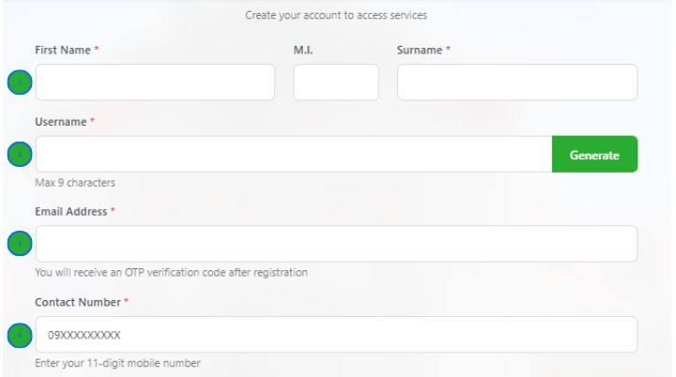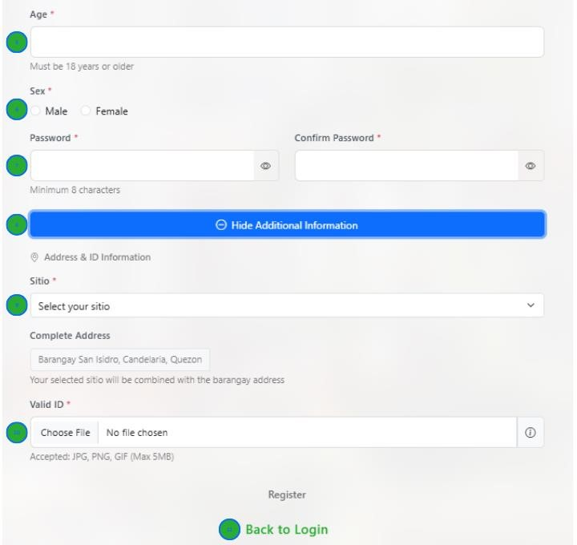

Figure 4. Registration
The registration form of the Web-Based E-Governance System is designed to collect accurate and verified user information while ensuring ease of use and security. During registration, users are required to enter their full legal name and create a unique username that will be used for future logins. An active email address is provided for account verification and system notifications, while a mobile contact number is collected to support communication and identity validation. Users also input their age and select their biological sex to assist in proper identification and record accuracy. To protect user accounts, the form requires users to create and confirm a secure password, with a hide or show password option included to enhance security and prevent input errors. The address feature allows users to enter their complete residential information through a guided prompt, ensuring standardized and complete address data. Additionally, users must upload a valid government-issued identification document, which helps barangay officials verify the authenticity of registrants and prevents fraudulent access. After completing the form, users may return to the login page to access the system. Overall, the registration form promotes data accuracy, user accountability, and system security, serving as a reliable foundation for trusted and efficient digital barangay services.
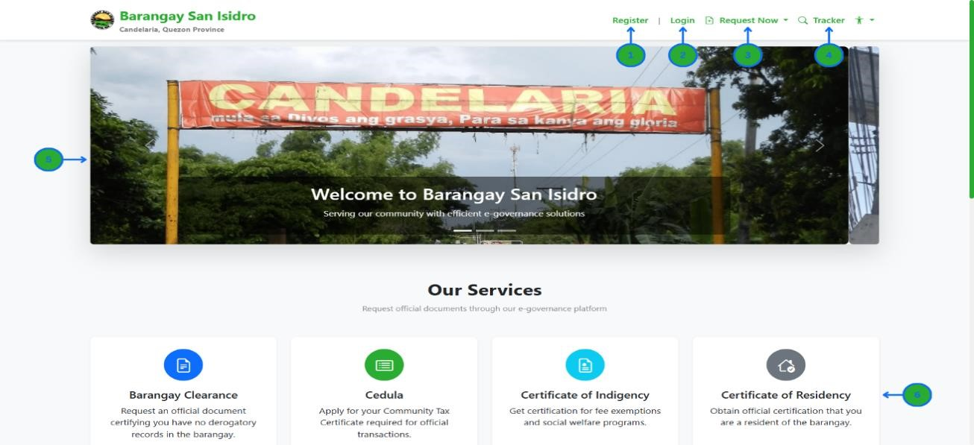
E.

User Dashboard

Figure 5. User Dashboard

On the Barangay San Isidro e-Governance homepage, users can easily register to create a new account or log in to access an existing one. The Quick Request feature allows residents to submit document requests efficiently, while the Tracker function provides real-time updates on the status of their requests. Users can also view the Announcements and Information section to stay informed about important notices from the barangay and browse the Document Services List to see and select available services. Once logged in, the user dashboard serves as a centralized space where residents can manage their profile, monitor requests, and track transaction history, making the overall process faster, organized, and user-friendly.

F. System Data Analytics
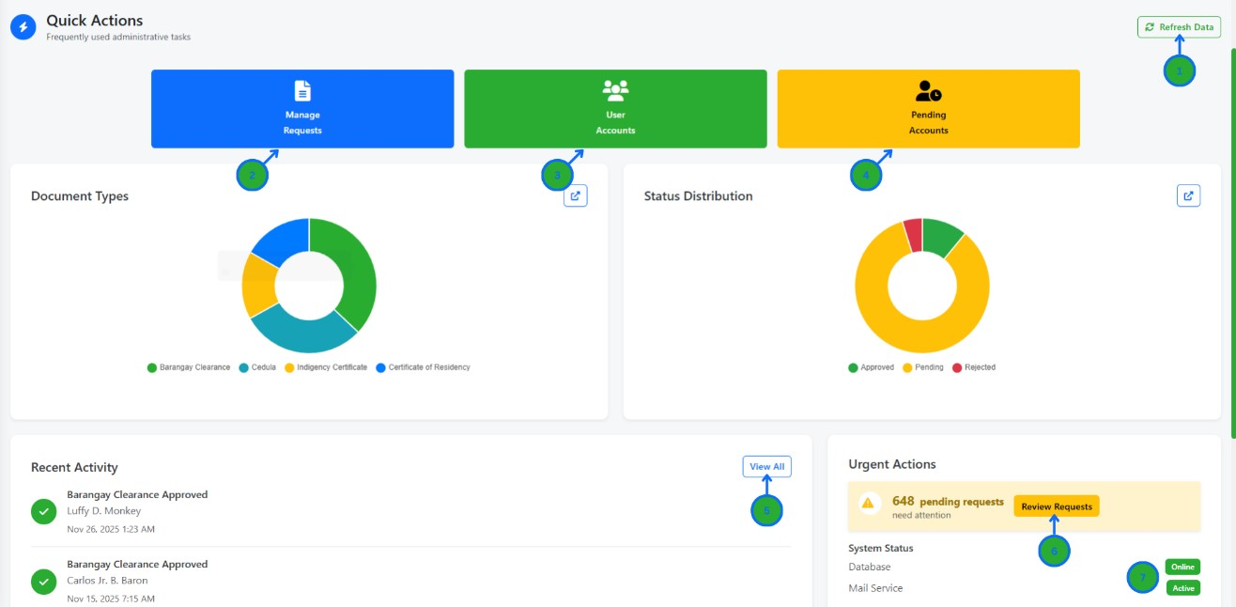

Figure 6. System Data Analytics
The System Analytics Dashboard gives administrators a clear, real-time overview of the platform’s operations through interactive charts, graphs, and status indicators. It allows admins to refresh data to ensure accuracy, manage and review document requests, oversee user accounts and pending registrations, and monitor recent activities for transparency and accountability. Urgent requests can be prioritized for faster action, while the system status indicator helps track server health and availability. Through system data analytics, administrators can identify request trends, monitor workload distribution, and make informed decisions to improve service efficiency, response time, and overall governance performance.

G. Admin System Dashboard
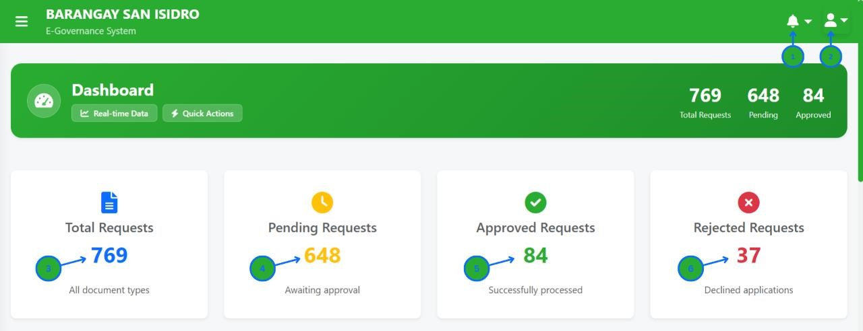

Figure 8. Admin System Dashboard
The Admin System Dashboard provides administrators with a centralized view of the e-governance platform, enabling efficient monitoring of document requests, notifications, and system activity. Through the notification bell and account profile, admins can stay updated and manage settings easily, while the dashboard panels display total, pending, approved, and rejected requests for quick assessment. This dashboard supports effective decision-making by giving real-time insights into request flow, approval progress, and system performance, helping administrators maintain transparency, prioritize tasks, and ensure smooth and timely service delivery.

H. Request History Page
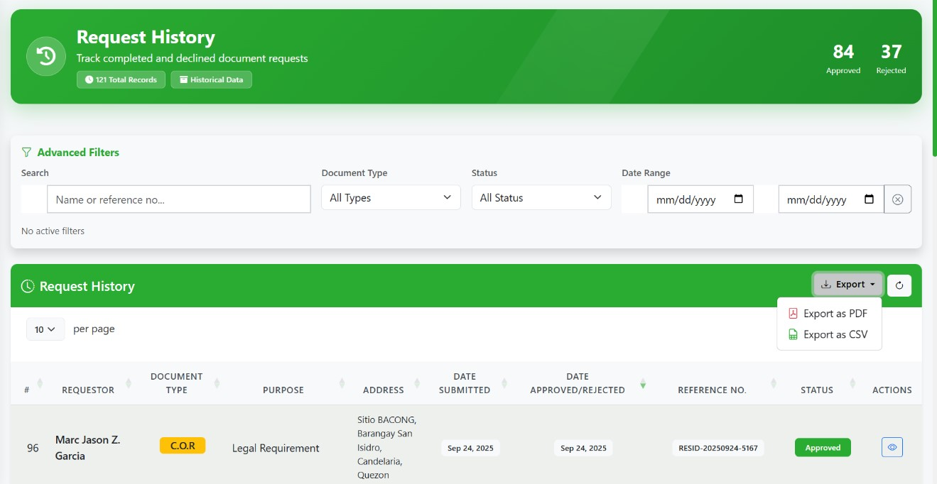

Figure 9. Request History Page
The Request History page allows administrators to track all completed and declined document requests using advanced filters such as name or reference number, document type, status, and date range. It provides a searchable and organized table showing requester details, document types, purposes, addresses, submission dates, approval or rejection dates, reference numbers, and current statuses. Administrators can also export the displayed records as PDF or CSV for reporting or record-keeping, and use the refresh button to update the list with the latest data.

IV. RESULTS AND DISCUSSION
Table 1

Overall Evaluation Result
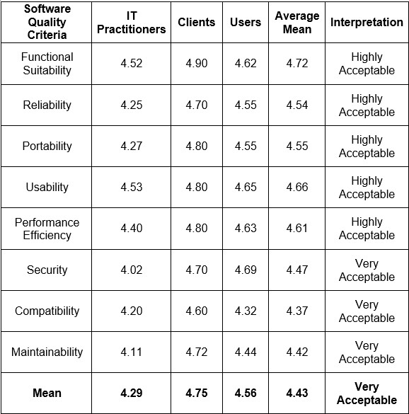

Table 1 summarizes the overall evaluation of the system based on the Software Quality Criteria. The average mean is 4.43, which is interpreted as “Very Acceptable”. Functional Suitability received the highest rating of 4.72, showing that the system performs its intended functions effectively. Usability and Performance Efficiency received mean scores of 4.66 and 4.61, indicating that the system is easy to use and operates efficiently. Reliability and Portability recorded mean scores of 4.54 and 4.55, indicating that the system performs consistently and functions well across different platforms. Security, Compatibility, and Maintainability obtained mean scores of 4.47, 4.37, and 4.42, respectively, which are still “Very Acceptable” and demonstrate that the system adequately protects data, works well with other systems, and can be maintained without major issues. Overall, the results show that the system performs effectively and is wellaccepted by IT Practitioners, Clients, and Users, demonstrating its readiness for continued use and future improvement.

V. RECOMMENDATIONS
Future enhancements may include the development of a mobile application, SMS or email notification features, and integration with other municipal or provincial systems. Additional analytics modules may also be implemented to support long-term planning and policy formulation. Based on the results of system testing and feedback from residents, barangay staff, and IT practitioners, several improvements are recommended to enhance the system’s performance, scalability, and usability. Rebuilding or upgrading the system using Laravel is advised, as it offers stronger security, better scalability, and easier maintenance for future expansion and integration with other barangay services. Adding an API for data sharing would also improve the system by enabling secure communication with other government platforms and supporting broader digital governance initiatives. Additionally, integrating clean audit logs is highly recommended to track user access, request updates, document downloads, and administrative changes, which would significantly improve transparency, accountability, and secure monitoring in a government-based document system.

VI. ACKNOWLEDGEMENTS
The researchers would like to formally acknowledge and express their sincere gratitude to all individuals and institutions whose invaluable support and contributions made the successful completion of this capstone project possible. This study would not have been achieved without the collective guidance, cooperation, and encouragement extended throughout its development.
First and foremost, the researchers offer their deepest thanks to God Almighty for the wisdom, strength, guidance, and good health granted to them, which sustained their perseverance and determination throughout the entire research process.
They would like to extend their heartfelt appreciation to Prof. Sherwin D. Quizon, their Research Adviser, for his continuous guidance, patience, and unwavering support. His expertise, constructive feedback, and dedication greatly shaped the direction and quality of this capstone project from its inception to completion.
The researchers are also sincerely grateful to Ms. Audrey E. Alinea, Mr. Michael Keith Alinea, and Mr. Hensonn A. Palomado for approving the capstone title and for providing insightful recommendations and evaluations that significantly enhanced the study’s content, structure, and overall relevance.
Special thanks are extended to Dr. Preciosa D. Villacruel, Interim University President of the Pamantasan ng Lungsod ng San Pablo, Prof. Jennifer D. Regoris, Director of
Research Development and Services, and Prof. Rosiell U. Consignado, Dean of the College of Computing Sciences and Engineering, for their administrative support, leadership, and commitment to fostering a research-driven academic environment that enabled the successful conduct of this project.
The researchers would also like to express their gratitude to Hon. George D. Suayan, Municipal Mayor of Candelaria, Quezon, and Ms. Aileen D. Panganiban, Chairwoman of Barangay San Isidro, for serving as the project clients. Their cooperation, trust, and openness in allowing the researchers to develop an e-governance system for their office greatly contributed to the practical relevance and real-world application of the study.
Sincere appreciation is extended to the IT Practitioners who generously shared their time and expertise in evaluating the system. Their technical insights, professional feedback, and constructive recommendations played a crucial role in refining the system’s functionality, security, and overall performance.
The researchers would also like to thank their friends for their encouragement, understanding, and emotional support, which helped maintain motivation and resilience during challenging stages of the project.
To their families, the researchers are deeply grateful for the unwavering emotional, moral, and financial support, as well as for their constant belief and encouragement, which served as a strong foundation throughout this academic journey.
The researchers extend their appreciation to BSIT 4B for the camaraderie, teamwork, and mutual support shared during their fourth year. The collective effort and positive environment fostered a sense of unity that contributed to both academic and personal growth.
Finally, the researchers would like to thank the Pamantasan ng Lungsod ng San Pablo for providing quality education, promoting innovation, and nurturing responsible and competent individuals. The institution’s commitment to academic excellence and research development played a vital role in shaping the researchers’ skills and values, ultimately making this capstone project possible.

REFERENCES
- Abesamis, L. R., & Caramancion, J. P. (2022). Strengthening public trust through digital transparency and accountability in local government. Philippine Journal of Digital Governance, 4(1), 33–47.
- Adnan, M., Rahman, S., & Malik, F. (2022). E-participation tools and their impact on democratic governance. Journal of Digital Government, 5(3), 44–59.
- Ahmad, M., Khan, S., & Ali, R. (2021). Mobile e-governance and its impact on public service delivery, transparency, and citizen satisfaction. International
Journal of Mobile Government, 5(2), 34–49.
- Ahmed, A. (2024). Assessing the impact of web-based systems on e-governance adoption. International Journal of E-Governance Studies, 12(1), 45–60
- Bajar, J., Santos, R., & Villamin, P. (2023). Digital transformation of Philippine LGUs during the COVID-19 pandemic. Journal of Public Administration and
Governance, 12(2), 58–76.
- Bajar, J. S., Mendoza, R., & Cruz, M. (2023). Digital transformation of Philippine local government units during the COVID-19 pandemic. Philippine Journal of Governance and Policy, 11(2), 65–84.
- Barangay Information Management System (BIMS). (2021). Municipality of San
Mateo, Rizal. San Mateo Local Government Unit. https://sanmateo.gov.ph
- Barangay Management Information System (BMIS). (2020). Department of the
Interior and Local Government (DILG). https://bmis.dilg.gov.ph
- Boedirochminarni, R. (2023). Digital governance as a driver for sustainable and inclusive urban development. International Journal of Smart Cities and
Governance, 7(1), 15–30.
- Bootstrap Team. (2023). Bootstrap documentation.
https://getbootstrap.com/
- Cambridge Dictionary (1999) – Cloud Storage.
https://dictionary.cambridge.org/dictionary/english/cloud-storage
- Cebu City Government. (n.d.). Online Business Permit and Licensing
System (OBPALS). Cebu City Official Website. https://cebu.gov.ph
- Chartjs.org. (2013). Chart.js: Interactive charts for data visualization. https://www.chartjs.org/docs/
- Chen, L. (2024). Modern approaches to real-time data analytics and decision-making. Journal of Data Science and Innovation, 12(1), 15–32.
- City Government of Valenzuela. (n.d.). Simple, Speed, and Service
Excellence (3S) Plus Online Services. https://valenzuela.gov.ph
- Coursera (2012) – Data Analytics. https://coursera.org/learn/introductionto-data-analytics
- Crawford, A. (2025). Using analytics for evidence-based governance and policy formulation. Governance and Public Innovation Journal, 18(1), 1–20.
- Davis, F. Technology Acceptance Model (TAM).
https://en.wikipedia.org/wiki/technology_acceptance_model
- De Castro, M. (2022). E-governance innovations in Quezon City:
Enhancing citizen engagement through digital platforms. Philippine Governance
Review, 10(3), 44–59.
- Department of Information and Communications Technology (DICT).
  - d.). e-Filipino Platform. https://dict.gov.ph
- Department of Information and Communications Technology (DICT).
  - d.). GovMail. https://dict.gov.ph
- Department of Information and Communications Technology (DICT).
  - d.). iGovPhil Project. DICT Philippines. https://dict.gov.ph
- Department of Information and Communications Technology (DICT).
  - d.). Philippine Government Common Platform (PGCP). https://dict.gov.ph
- Department of the Interior and Local Government (DILG). (n.d.). LGU
Monitoring and Evaluation System. DILG Philippines. https://dilg.gov.ph
- DSHS (1970) – Web-Based System. https://dshs.wa.gov/faq/what-webbased-system
- E-Barangay System – Los Baños, Laguna. (2019). Municipality of Los
Baños. https://losbanos.gov.ph
- Grepix Infotech. (2024). Cost-effectiveness and advantages of web-based information systems. Grepix Publications.
- Grunberg, M. (2024). Data-driven performance management for small and medium enterprises. Business Analytics Review, 6(2), 71–89.
- Haque, A. B. (2022). Semantic web in healthcare: A systematic literature review of applications, research gaps, and future directions. Journal of Health
Informatics and Technology, 14(1), 1–22.
- Johnson, L. (2023). Web-based systems and modern software deployment. International Journal of Web Technology Studies, 8(1), 21–35.
- Kang, H. (2023). The role of data analytics in business growth and strategic success. International Journal of Business Intelligence, 9(3), 44–59.
- Lerdorf, R., Tatroe, K., & MacIntyre, P. (2020). Programming PHP (4th ed.). O’Reilly Media.
- Magana, S., Rodriguez, L., & Rivera, C. (2025). Digital governance and public involvement in modern government systems. International Journal of EGovernment Studies, 9(1), 1–18.
- Magana, S. R., Villanueva, D., & Santos, K. (2025). Understanding digital governance and public involvement in the 21st century. Journal of E-Government Innovation, 7(1), 12–30.
- Nasrudin, N. (2020). E-governance and its role in achieving Sustainable Development Goals (SDGs). Journal of Global Public Policy, 6(4), 72–88.
- OpenJS Foundation. (2022). JavaScript: The definitive guide to web development. OpenJS Documentation.
- Othman, R., Razali, N., & Nasrudin, N. (2020). E-governance as a catalyst for sustainable development: A Southeast Asian perspective. Asian Journal of Public Policy, 5(2), 101–119.
- Pacano, E. A., & Tayaoan, H. M. B., et al. (2024). Digital platforms for improving public service delivery in Philippine local government units. Philippine Journal of Modern Governance, 8(1), 90–108.
- Pacano, E. A., & Tayaoan, H. M. B., et al. (2024). E-governance initiatives in the Philippines: Improving service delivery through digital platforms. Philippine Journal of Public Administration, 68(1), 101–119.
- Palma, J. P. B., Reyes, A. L., & Aquino, M. J. (2023, April). Smart city egovernance channels: Web portals, social media, mobile apps, and web applications. Asian Journal of Smart Technologies, 4(2), 55–70.
- Pasig City E-Governance System. (2020). City Government of Pasig.
https://pasigcity.gov.ph
- Rouse, M. (2021). E-governance: Definition and components. TechTarget. https://www.techtarget.com
- Shadbolt, P. (2024). Optimizing public service delivery through advanced data analytics. Public Administration and Digital Governance Quarterly, 10(2), 55–73.
- Shaikh, A., Kumar, P., & Yousaf, S. (2023). Digital platforms for citizen engagement: Global trends in e-governance. International Review of ICT and Governance, 15(3), 98–114.
- Sharma, R., & Gupta, P. (2023). Cloud computing applications in egovernance: Secure document storage and record management. International Journal of E-Governance and Information Systems, 9(2), 112–126.
- Shkarlet, S., Kharazishvili, Y., & Kolot, A. (2020). Challenges in adopting egovernance systems in developing countries. International Journal of ICT and Public Sector Management, 3(2), 55–73.
- Supabase. (2024). Supabase documentation: Open-source backend as a service. https://supabase.com/docs
- Taguig City Online Document Request System. (2021). City Government of Taguig. https://taguig.gov.ph
- Technology, M. (2023). Advantages of web-based systems in business and government applications. Modern IT Solutions.
- TechTarget (1999) – Hardware.
https://techtarget.com/searchnetworking/definition/hardware
- Technopedia (2010) – Online Services. https://techopedia.com/definition/online-service
- Tammy, R. (2024). Data transparency and sustainability reporting in modern organizations. Journal of Environmental and Social Governance, 5(4), 112–129.
- Troy, A., Bajar, J., & Porsche-Ludwig, M. (2021). Quezon City’s awardwinning digital governance model: Replicable practices for urban modernization.
Urban Governance Innovations Review, 6(2), 21–39.
- United Nations Department of Economic and Social Affairs. (2022). EGovernment Survey 2022: The future of digital government. United Nations.
- Waheduzzaman, M. (2022). The role of WSIS in promoting global eparticipation. United Nations ICT Review, 9(4), 34–47.
- Wensheng, G. (2023). The emergence of Web 3.0: Decentralized architecture and future Internet security. Journal of Advanced Internet Research, 11(3), 120–139.
- Wharton Business School. (2021). Customer insights and digital behavior analytics. Wharton Publishing.
- Wikipedia (2003) – Barangay. https://en.wikipedia.org/wiki/Barangay
- Wikipedia (2001) – Software. https://en.wikipedia.org/wiki/Software
- Wikipedia (2001) – Transparency. https://en.wikipedia.org/wiki/Transparency [61] World Bank. (2020). Digital government transformation: Leveraging technology for improved public service delivery. World Bank Publications.
[62] Yildiz, M. (2022). E-government research: Reviewing the literature and future directions. Government Information Quarterly, 39(3), 101–118.

